**6th Grade Assignments-ELA and Social Studies.**

Students are expected to work daily in ELA and Social Studies Assignments. It is recommended that they spent at least 2 hours daily on the work assigned.

Students were sent home with a packet to practice for coming NYS ELA Exam. The packet is expected to be completed and returned back to school.

Also, students will have assignments assign to them online through cleaver on their benchmark account. The assignments in ELA will be Leveled Readers from Benchmark and a worksheet with questions that goes with the book that is assigned to each student.

<https://yonkerspublicschools.benchmarkuniverse.com/?#library/switchProgram/Benchmark%20Advance%20c2018>

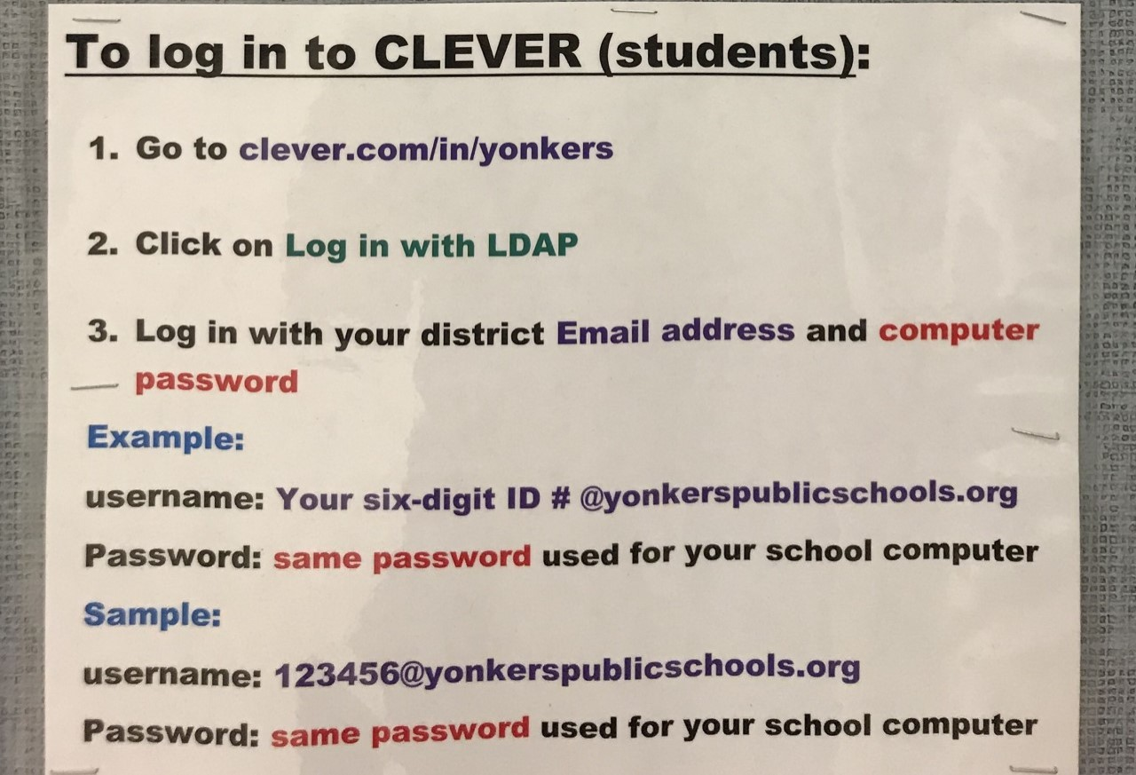

**Day 1:**  Romans 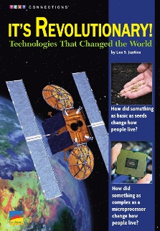 Greeks 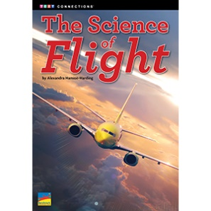

* Have your child analyze the text features of the book: For example, read the title predict what the book is about based on the title, look at the photos through the book and analyze each photo and the captions.
* Read chapters 1-2/sections and circle any words that you don’t know, use context clues or a dictionary to find the meaning to help you with comprehension.
* Write day 1 and date in the reading notebook and write the vocabulary words for chapters 1-2/sections. Also, write the definition next to each word and use the vocabulary words in a sentence.
* After you read chapters 1-2/sections at least 2 times, use the text features in the text and the reading sections to find the main idea and identify the key details that support that main idea.
* Write the date, the title of the book, chapters/sections as a heading. Then, write the main idea and the key details in the reading notebook.

**Day 2:**

* Do Now- Summarize the main Idea and the key details from chapters 1-2/sections. Write your summary in your reading  
   notebook.
* Then, read chapters 3-4 and follow the same steps that you did day 1.
* Write day 2 and date in your reading notebook and write the vocabulary words for chapters 3-4. Write

The definitions next to each word and use them in a sentence.

* After you read chapters 3-4/sections at least 2 times, use the text features in the text, and the reading sections to find the main idea and identify the key details that support that main idea.
* Please write the date, the title of the book, chapters/sections as a heading. Then, write the main idea and the key details in the reading notebook.

**Day 3:**

* Do Now- Summarize the main Idea and the key details from chapters 3-4. Write your summary in your reading notebook.
* Then, read chapters 5-6/sections and follow the same steps that you did for day 2, for chapters 3-4/sections.
* Write day 2 and date in your reading notebook and write the vocabulary words for chapters 5-6. Write

the definitions next to each word and use them in a sentence.

* After you read chapters 5-6/sections at least 2 times, use the text features in the text, and the reading sections to identify the main idea and the key details that support that main idea.
* Please write the date, the title of the book, chapters/sections as a heading. Then, write the main idea and the key details in the reading notebook.

**Day 4**

* Answer 4 Text Evidence Questions in your reading notebook. (Questions 1-4)
* Write the questions and the answer in your reading notebook.
* Make sure you are using the RACE strategy to answer the Text Evidence Questions.
* Castle Learning- 2018 Grade 6 NYS ELA Sampler Session 1

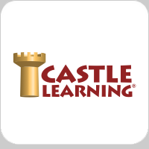Go to clever and click on the Castle Learning Icon

**Day 5:**

* Answer 4 Text Evidence Questions in your reading notebook. (Questions 4-8)
* Write the questions and the answer in your reading notebook
* Make sure you are using the RACE strategy to answer the Text Evidence Questions.
* Castle Learning- 2018 Grade 6 NYS ELA Sampler Session 2

**Day 6:**

* Answer 4 Text Evidence Questions in your reading notebook. (Questions 9-12)
* Write the questions and the answer in your reading notebook.
* Make sure you are using the RACE strategy to answer the Text Evidence Questions.
* Castle Learning- 2018 Grade 6 NYS ELA Sampler Session 2.

 Go to clever and click on the Castle Learning Icon

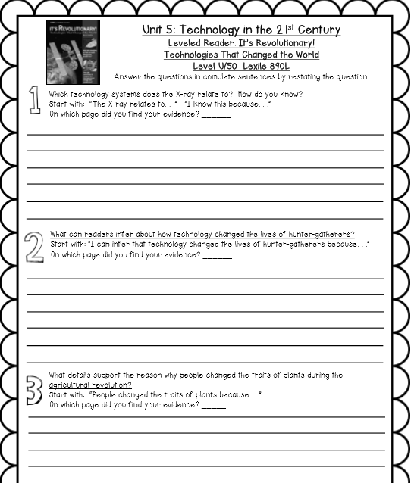

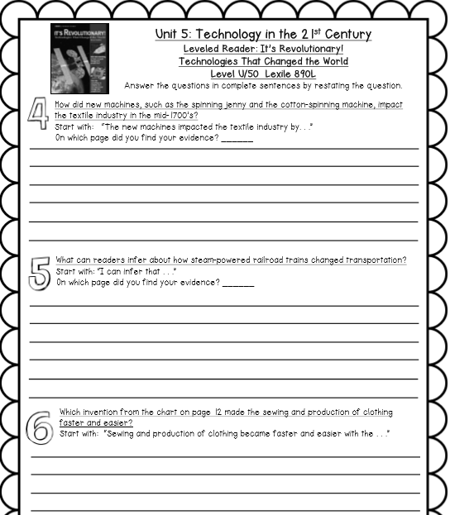

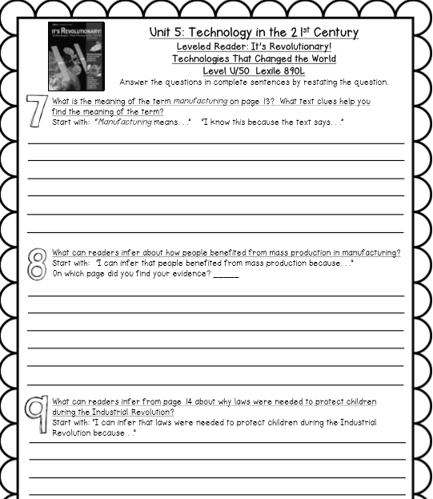

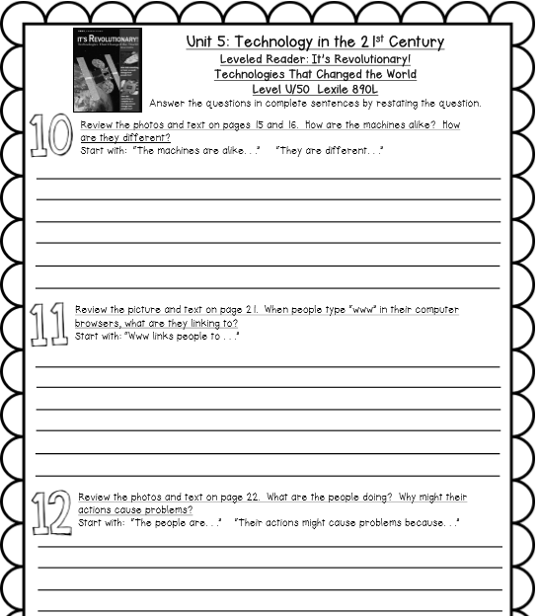

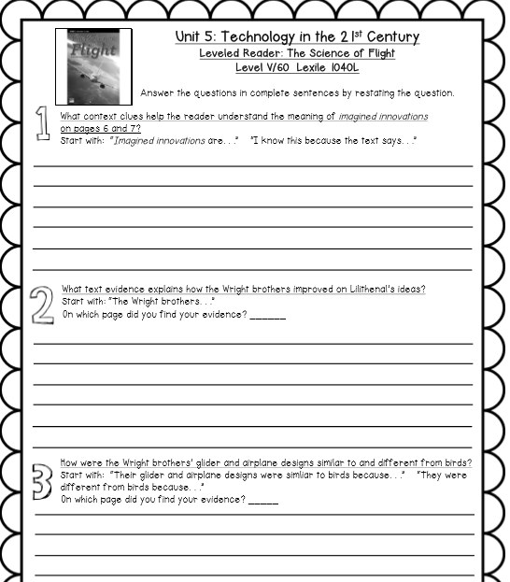

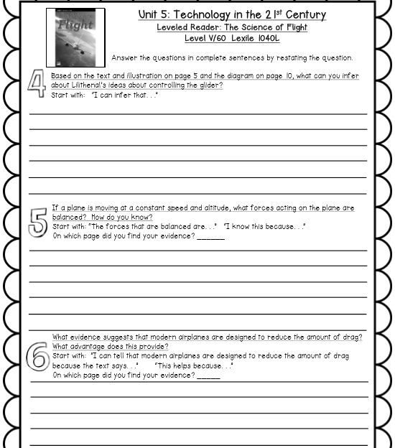

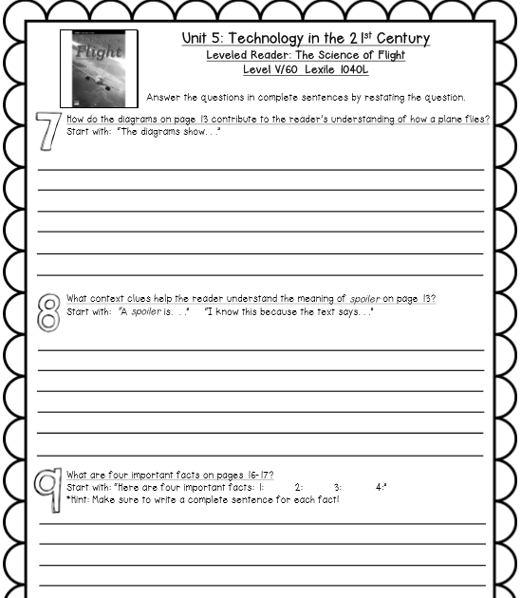

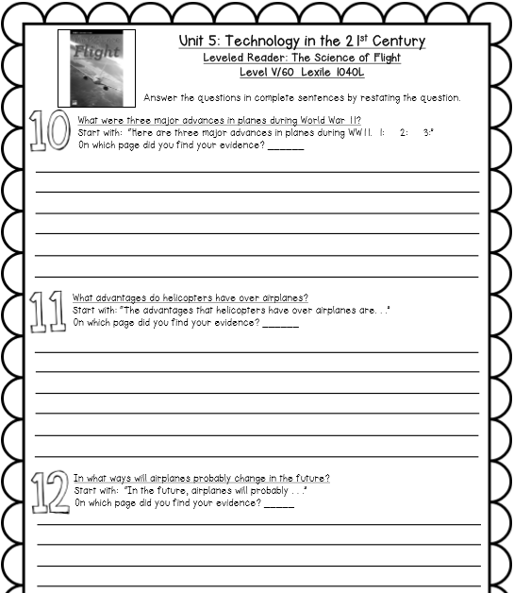

**Social Studies** (Sample Pacing Guide)

|  |  |
| --- | --- |
| **Days** | **Instructions** |
| 1 | Decide the 5 topics that you want to include in your brochure. (read the directions for the project)  Do a research of the first 3 topics and write down at least 6 interesting facts you want to include in your brochure in your Social Studies notebook. Be sure that your notes are in your own words.  Write down the link of the website you got the information from. |
| 2 | Do a research of the next 2 topics and write down the most important facts you want to include in your brochure. (read the directions for the project on the page below)  Be sure that your notes are in your own words.  Write down the link of the website you got the information from. |
| 3 | Work on the **Cover Paige** of the brochure (Read the directions for the project)  (Title, Illustrations) |
| 4 | Work on the **Body Paige** (Read the directions for the project)  (Facts about the topic that you chose and pictures) |
| 5 | Work on the **Body Paige** (Read the directions for the project)  (Facts about the topic that you chose and pictures) |
| 6 | Finish your Brochure (Read the directions for the project) |

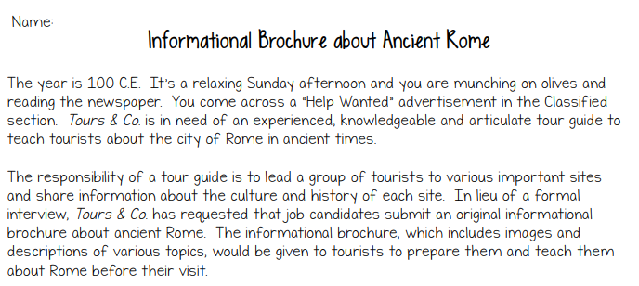

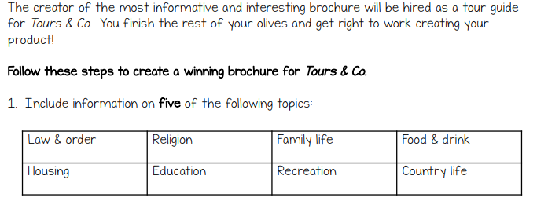

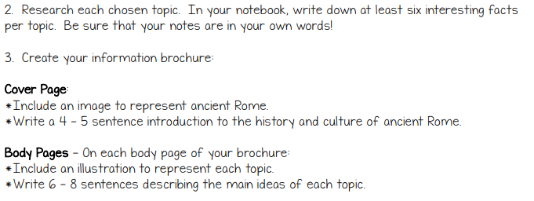

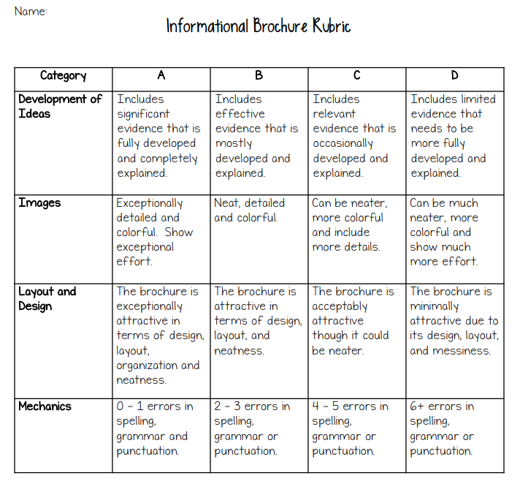

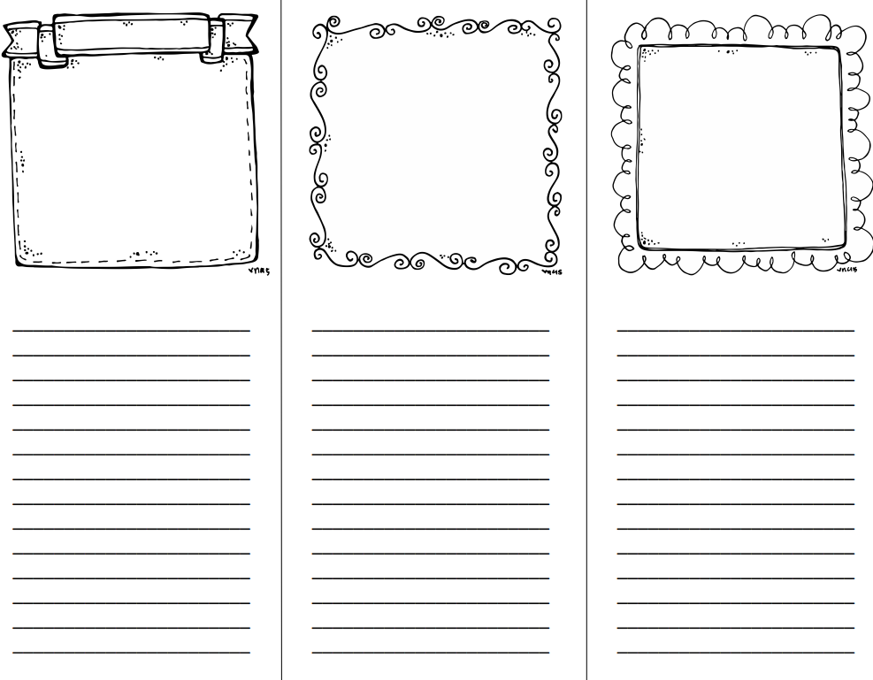



**Grade 6**

**English Language Arts**

**&**

**Social Studies**

**Name**

**Mrs. Frroku/Greeks**



**Grade 6**

**English Language Arts**

**&**

**Social Studies**

**Name**

**Mrs. Frroku/Romans**